Creating a New Page
- Create the Page in Content Management
  - Go to the Page Maintenance screen in 365 and click the “Add a New Page Button” F.1
  - Give the page a Name. Give the Form a Name and Description and prefix it with 365 (usually the same as the Page Name). Click Save F.2
- Retreive the newly created page record from the database and add it to the scripts.
  - Go to NGLMASDATA\DataMigrationScripts\Deployment Generators and run the script generateCreatePageScript.sql
  - Copy the results for the record you just created and paste the script at the end of NGLMASDATA\dbo\Stored Procedures\spInsertAllCMPages.sql F.3
- Create the aspx page in the DynamicsTMS365 solution.
  - Give the file the same name you gave the page and the form in the previous step F.4
- Add the new page to the PageEnum enumerator in 365
  - DynamicsTMS365\Utilities.cs - add the new page to the enumerator PageEnum F.5
    - The PageControl was assigned automatically when the page was created via the UI – get this value from the script we added to spInsertAllCMPages. It is the first numeric parameter value. Or get it from database table cmPage F.6
- Set the correct PageControl value in the page behind
  - Open the aspx.cs page behind file for the new page.
  - Make sure the PageControl is pointing to the correct PageEnum value F.7

Constructing the ASPX.CS Page Behind (Basic Template)
BingMapsJS
PageControl
UserControl
PageControl
UserTheme
PageFooterHTML
AuthLoginNotificationHTML
PageMenuTab
PageReadyJS
FastTabsHTML
FastTabsJS
PageTemplates
PageCustomJS
PageArrayDataJS
PageErrorsOrWarnings

Constructing the ASPX Page (Basic Template)
<% Response.Write(PageTemplates); %>
<%-- HelpWindow needs to go after AuthNotification because it uses the notification object created there --%>
<% Response.Write(AuthLoginNotificationHTML); %>
<% Response.WriteFile("~/Views/HelpWindow.html"); %>
execActionClick()
etc.

Creating the Menu Tab

Add an Action Menu Button
Add buttons to the Action Menu for the Page
- Open NGLMASDATA\dbo\Stored Procedures\spInsertAllCMPageMenu.sql
- Go to the section of the file for your page. If one does not yet exist, create it F.8
- Copy an existing script line and edit the following values to fit your new button F.9
  - ProcedureName – Allows for access control via Role Center Permissions
  - PageControl – The Control of the page to which you are adding the Action Menu button
  - Button Name – The name of the button, in both the database table and HTML id
  - Button Caption/Local – The text that appears with the button in the Action Menu
  - Sequence – Controls the order in which the buttons appear in the Action Menu
  - Icon – The icon that appears with the button in the Action Menu
  - Type – Indicates if this button will appear in the Action Menu (1) or Navigation Menu (2)
Add JavaScript to execute the action logic
- Go to the .aspx file for the page to which you have added the Action button in the previous step
- Modify the JavaScript function execActionClick() F.10
  - Add an if-else statement for your button (execute the logic inside the if statement)
  - If execActionClick() does not yet exist create it – examples can be found on other pages

Add a Navigation Menu Button
Add buttons to the Navigation Menu for the Page
- Open NGLMASDATA\dbo\Stored Procedures\spInsertAllCMPageMenu.sql
- Go to the section of the file for your page. If one does not yet exist, create it F.8
- Copy an existing script line and edit the following values to fit your new button F.11
  - ProcedureName – Allows for access control via Role Center Permissions
  - PageControl – The Control of the page to which you are adding the Navigation button
  - Button Name – The name of the button, in both the database table and HTML id
  - Button Caption/Local – Text that appears with the button in the Navigation Menu
  - Sequence – Controls the order in which the buttons appear in the Navigation Menu
  - Icon – The icon that appears with the button in the Navigation Menu
  - Type – Indicates if this button will appear in the Action Menu (1) or Navigation Menu (2)
Add JavaScript to execute the navigation logic
- Go to the .aspx file for the page to which you have added the Navigation button previously
- Modify the JavaScript function execActionClick() F.10
  - Add an if-else statement for your button (execute the logic inside the if statement)
  - If execActionClick() does not yet exist create it – examples can be found on other pages

Add a Report Menu Button
Add buttons to the Report Menu for the Page
- Open NGLMASDATA\dbo\Stored Procedures\spInsertAllCMPageMenu.sql
- Go to the section of the file for your page. If one does not yet exist, create it F.12
- Copy an existing script line and edit the following values to fit your new button F.13
  - ReportName – Allows for access control via Role Center Permissions
  - PageControl – The Control of the page to which you are adding the Report button
  - Button Name – The name of the button, in both the database table and HTML id
  - Button Caption/Local – Text that appears with the button in the Report Menu
  - Sequence – Controls the order in which the buttons appear in the Report Menu
  - Icon – The icon that appears with the button in the Report Menu
Add JavaScript to execute the report logic
- Go to the .aspx file for the page to which you have added the Report button previously
- Modify the JavaScript function execReportClick () F.14
  - Add an if-else statement for your button (execute the logic inside the if statement)
  - If execReportClick () does not yet exist create it – examples can be found on other pages

For example (try to clean this up for me)
- Create ASPX page data (where does this happen before or after content management)
- Create new Controller class for data
  - Constructor
  - Data transformation
    - Select models
    - Select lts
    - Etc.
  - Get
  - GetRecords
  - GetAllRecords
  - Post
  - Delete
  - Naming conventions and all that
- Open content management and click add new page
  - Add steps like enter new name etc…
  - Update x stored procedures with page data
  - Update y page enumerators
  - Update z deployment scripts
- Create the Data Grid or data content container
  - Link to the table or view for data
  - Click add fields (etc…)
  - Grid CRUD Ctrl Widget
  - Grid button
  - Filters
- Add Action Menu Item
  - Update default security procedures/Sql scripts for roles (define how this is done and where)
i. Add actions to the action menu for the page (define how this is done)
ii. Add javascript to execute the action logic (provide a simple example)
- Duplicate #5 for Navigation and Reports.
- Update ASPX code behind for content management
  - List minimum requirements
- Update ASPX page code requirements
  - List minimum requirements
- List anything else that may be required
- How to do a ddl
- How to do an edit on page control
- How to do a popup window
- Summary Ctrl
- Whatever other cm optons

Pictures

New Page

Figure 1
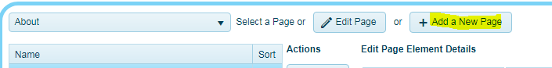

Figure 2
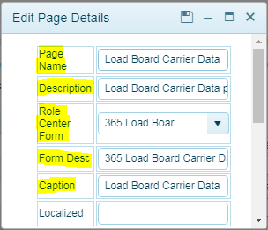

Figure 3

Figure 4
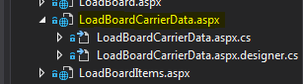

Figure 5
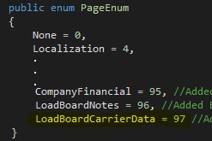

Figure 6

Figure 7
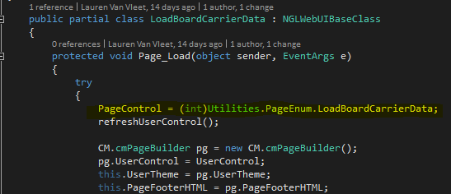

Action Menu

Figure 8
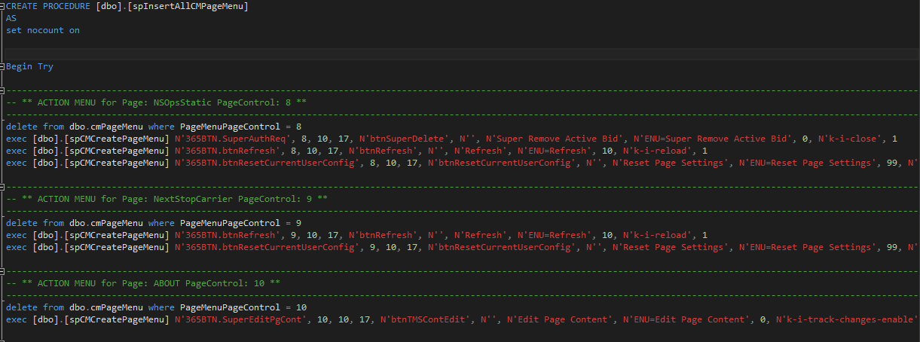

Figure 9

Figure 10
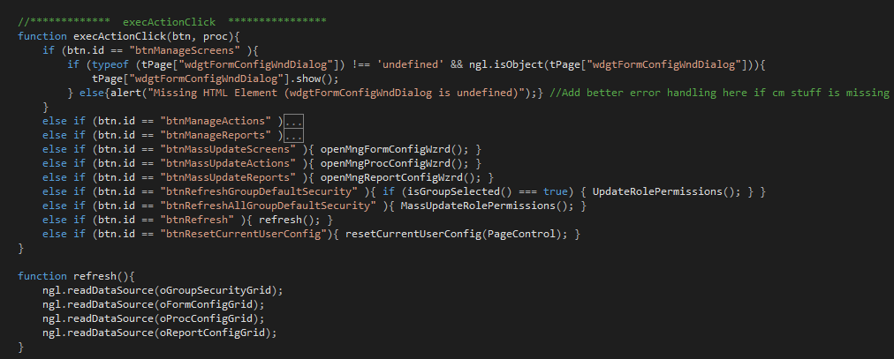

Figure 11

Report Menu

Figure 12
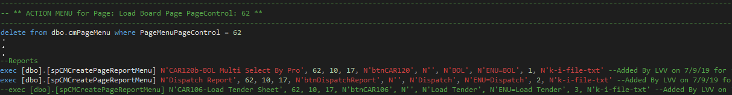

Figure 13

Figure 14
